|  |
| --- |
| SAMPLE CASE STUDY: PAY JUNCTION |

Background

Pay Junction is a company that performs order processing and manages payment realizations for other organizations.

Existing System

Pay junction maintains separate files for storing customer details and order details. The Customer Details file consists Of records such as customer code, customer name, company name, address, country, phone number, and billing address.

When an order is processed, various parameters that affect the order are filled in a form and then analyzed. The format of the Order Processing form is shown in the following figure.

|  |  |
| --- | --- |
| Order code: Customer code:  product code:  Quantity:  Discount:  SHIPMENT DETAILS Shipment Name:  Shipping Country:  Shipping Date:  Shipping Mode:  Tax: | ORDER PROCESSING  Order Details code:  Order Date:  product Name:  Unit Price:  Shipping Address:  Contact Phone:  Shipping Mode ID:  Freight Charges:  Total Value: |



The data related to the order and shipment is transferred from the Order Processing form to the Orders file. The data related to the products ordered is stored in the Products file.

The payments for orders are accepted through cash or credit card. When the customer makes the payment, the Payments file is updated with the data about payment code, order code, payment amount, payment date, payment mode ID, payment mode, and credit card details if the customer pays through a credit card. The credit card details consist of card number, cardholder's name, and card expiry date

# Envisioned System

Pay junction has decided to stop manual data storage and start computerized database management and order processing. This would also enable the company to have quicker communication with the clients.

A small group of database designers have been deployed by Pay Junction to develop a computerized system Of order processing and database management. pay Junction also wants to include the information about an employee who processes an order. This information will include the employee code, name, title, and phone number.

The development team needs to perforrn the following activities:

Identify the various entities involved

1. Identify the attributes that completely define the entities.
2. Draw an E/R diagram to demonstrate the relationship between the various entities.
3. Map the E/R diagram to the tables.
4. Normalize the tables to 3 NF.
5. Identify the primary and foreign keys in the tables.
6. Draw a diagram to show the relationships between the various tables.

C' NIIT



# PROJECT ON

Pay Junction

Developed by

Name: Debbie Howe

Reg. NO. : 4701-10-258

# NIIT



@ NIIT

Pay Junction

(project Tide)

|  |  |  |
| --- | --- | --- |
| Batch Code  Start Date  Name of the Coordinator  Name of Developer  Date of Submission | : June 1, 2007 : Alex Norton : Debbie Howe  : June 11, 2007 | End Date: June 10, 2007 |



## MIT

|  |
| --- |
| CERTIFICATE  This is to certify that this report titled Pay Junction embodies the original work done by Debbie Howe in partial fulfillment of their course requirement at NIIT.  Coordinator:  A/ex Norton |



@ NIIT

### ACKNOWLEDGEMENT

We have benefited a lot from the feedback and suggestions given to us by Mr. Alex Norton and other faculty members

### SYSTEM ANALYSIS

System Summary: Pay Junction is a company that has been taken up by a leading leather accessories manufacturer for order processing and managing payment realizations. Pay Junction maintains separate files for storing customer details and order details. When an Order is processed, various parameters that affect the Order are filled in a form and then analyzed. The payments for orders are accepted through cash or credit card

ENTITIES

Number Of entities: 5 Names of entities:

1 Customers

1. Orders
2. Products
3. Payments
4. Empl oyees

ATTRIBUTES

|  |  |  |  |  |  |  |  |  |  |  |
| --- | --- | --- | --- | --- | --- | --- | --- | --- | --- | --- |
| Attributes:  The various entities and their attributes are listed in the following table.   |  |  | | --- | --- | | Entity | Attributes | | Customers | Cust-Code  First Name  Last Name  Address Country  Zip Code  Phone No | | Orders | Order-Code  Cust-Code Prod-Code  Emp-Code  Order-Dt  Ship Name  Ship Address  Ship Country  Ship Phone  Ship-Dt  Ship Method Id  Ship Method Freight Charge sales Tax Quantity  Discount  Total Cost | | Products | Prod-Code  Prod-Name  Description  Unit Price | | Payments | Payment-Code  Order-Code Payment Amount payment-Dt  Payment Mode Id  Payment Mode  CreditCard No  Cardholders Name  CreditCardEx i -Dt | |

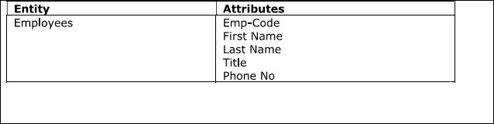

E/R DIAGRAM

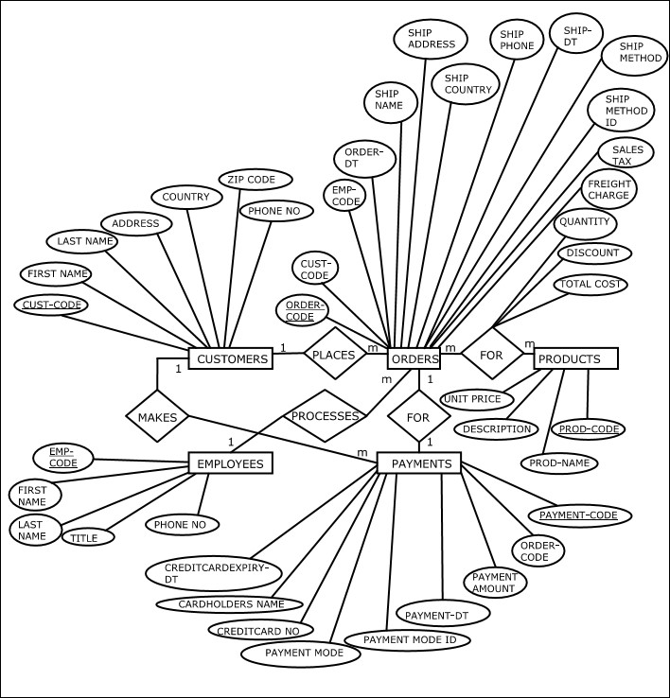

TABLES

|  |  |  |  |  |  |  |  |  |  |  |  |  |  |  |  |  |  |  |  |  |  |  |  |  |  |  |  |  |  |  |  |  |
| --- | --- | --- | --- | --- | --- | --- | --- | --- | --- | --- | --- | --- | --- | --- | --- | --- | --- | --- | --- | --- | --- | --- | --- | --- | --- | --- | --- | --- | --- | --- | --- | --- |
| Number Of Tables: 6  Structure of Tables: The table structures are shown here  Customers [Entity] Orders [Entity] Order Details [Relationship]   |  |  |  |  |  |  |  |  |  |  |  |  |  |  |  |  |  |  |  |  |  |  |  |  |  |  |  |  |  |  |  |  | | --- | --- | --- | --- | --- | --- | --- | --- | --- | --- | --- | --- | --- | --- | --- | --- | --- | --- | --- | --- | --- | --- | --- | --- | --- | --- | --- | --- | --- | --- | --- | --- | | |  | | --- | | Customers | | cust-code | | First-Name | | Last-Name | | Address | | Country | | Zip-code | | Phone-No | | |  | | --- | | Orders | | O Code | | Cust- Code | | Emp-Code | | Order-Dt | | Ship-Name | | Ship-Address | | Ship-country | | Ship-Phone | | Ship-Dt | | Ship-Method-ID | | Ship-Method | | Freight-charge | | Sales-Tax | | |  | | --- | | Order Details | | orderDetaiI-1D | | Order-Code | | Prod-Code | | Quantity | | Discount | | Total-cost | | |

|  |  |  |  |  |  |  |  |  |  |  |  |  |  |  |  |  |  |  |  |  |  |  |  |  |
| --- | --- | --- | --- | --- | --- | --- | --- | --- | --- | --- | --- | --- | --- | --- | --- | --- | --- | --- | --- | --- | --- | --- | --- | --- |
| Products [Entity] Payments [Entity] Employees [Entity]   |  |  |  |  |  |  |  |  |  |  |  |  |  |  |  |  |  |  |  |  |  |  |  |  | | --- | --- | --- | --- | --- | --- | --- | --- | --- | --- | --- | --- | --- | --- | --- | --- | --- | --- | --- | --- | --- | --- | --- | --- | | |  | | --- | | products | | Prod-Code | | Prod-Name | | Description | | Unit- Price | | |  | | --- | | payments | | Payment- Code | | Order-Code | | payment-Amount | | Payment-Dt | | Payment-Mode- ID | | payment-Mode | | Credit Card-No | | Card Holders-Name | | CreditCardExpiry-Dt | | |  | | --- | | Em ployees | | Emp-Code | | First-Name | | Last- Name | | Title | | Phone-No | |   The Order Details table is formed because of a many-to-many relationship between the Orders and Products entities. |



TABLES AFTER 1 NF

|  |  |  |  |  |  |  |  |  |  |  |  |  |  |  |  |  |  |  |  |  |  |  |  |  |  |  |  |  |  |  |  |  |
| --- | --- | --- | --- | --- | --- | --- | --- | --- | --- | --- | --- | --- | --- | --- | --- | --- | --- | --- | --- | --- | --- | --- | --- | --- | --- | --- | --- | --- | --- | --- | --- | --- |
| The tables are already in 1 NF. The table structures are shown here.  Customers Orders Order Details   |  |  |  |  |  |  |  |  |  |  |  |  |  |  |  |  |  |  |  |  |  |  |  |  |  |  |  |  |  |  |  |  | | --- | --- | --- | --- | --- | --- | --- | --- | --- | --- | --- | --- | --- | --- | --- | --- | --- | --- | --- | --- | --- | --- | --- | --- | --- | --- | --- | --- | --- | --- | --- | --- | | |  | | --- | | Customers | | Cust-Code | | First-Name | | Last-Name | | Address | | Country | | Zip-code | | Phone-No | | |  | | --- | | Orders | | Order-Code | | Cust- Code | | Emp-Code | | order-Dt | | Ship-Name | | Ship-Address | | Ship-Country | | Ship-phone | | Ship-Dt | | Ship-Method-1D | | Ship-Method | | Freight-Charge | | Sales-Tax | | |  | | --- | | Order Details | | OrderDetaiI-1D | | Order-Code | | Prod-Code | | Quantity | | Discount | | Total-Cost | | |

|  |  |  |  |  |  |  |  |  |  |  |  |  |  |  |  |  |  |  |  |  |  |  |  |  |
| --- | --- | --- | --- | --- | --- | --- | --- | --- | --- | --- | --- | --- | --- | --- | --- | --- | --- | --- | --- | --- | --- | --- | --- | --- |
| Products Payments Employees   |  |  |  |  |  |  |  |  |  |  |  |  |  |  |  |  |  |  |  |  |  |  |  |  | | --- | --- | --- | --- | --- | --- | --- | --- | --- | --- | --- | --- | --- | --- | --- | --- | --- | --- | --- | --- | --- | --- | --- | --- | | |  | | --- | | products | | Prod-Code | | Prod-Name | | Description | | Unit- price | | |  | | --- | | payments | | Payment- Code | | Order-Code | | Payment-Amount | | payment | | Payment-Mode- ID | | pa Mode | | Credit Card- No | | Card Holders-Name | | CreditCardExpiry-Dt | | |  | | --- | | Employees | | Emp-Code | | First-Name | | Last-Name | | Title | | Phone-No | | |



TABLES AFTER 2 NF

|  |  |  |  |  |  |  |  |  |  |  |  |  |  |  |  |  |  |  |  |  |  |  |  |  |  |  |  |  |  |  |  |  |
| --- | --- | --- | --- | --- | --- | --- | --- | --- | --- | --- | --- | --- | --- | --- | --- | --- | --- | --- | --- | --- | --- | --- | --- | --- | --- | --- | --- | --- | --- | --- | --- | --- |
| The tables are already in 2 NF as the attributes in each table depend on the primary key. The table structures are shown here.  Customers Orders Order Details   |  |  |  |  |  |  |  |  |  |  |  |  |  |  |  |  |  |  |  |  |  |  |  |  |  |  |  |  |  |  |  |  | | --- | --- | --- | --- | --- | --- | --- | --- | --- | --- | --- | --- | --- | --- | --- | --- | --- | --- | --- | --- | --- | --- | --- | --- | --- | --- | --- | --- | --- | --- | --- | --- | | |  | | --- | | Customers | | cust-code | | First-Name | | Last-Name | | Address | | Country | | Zip-code | | Phone-No | | |  | | --- | | Orders | | Order-Code | | Cust-Code | | E mg-Code | | Order-Dt | | Ship-Name | | Ship-Address | | Ship-country | | Ship-phone | | Ship-Dt | | Ship-Method-ID | | Ship-Method | | Freight-charge | | Sales-Tax | | |  | | --- | | Order Details | | orderDetaiI-1D | | Order-Code | | Prod-Code | | Quantity | | Discount | | Total-cost | | |

|  |  |  |  |  |  |  |  |  |  |  |  |  |  |  |  |  |  |  |  |  |  |  |  |  |
| --- | --- | --- | --- | --- | --- | --- | --- | --- | --- | --- | --- | --- | --- | --- | --- | --- | --- | --- | --- | --- | --- | --- | --- | --- |
| Products Payments Employees   |  |  |  |  |  |  |  |  |  |  |  |  |  |  |  |  |  |  |  |  |  |  |  |  | | --- | --- | --- | --- | --- | --- | --- | --- | --- | --- | --- | --- | --- | --- | --- | --- | --- | --- | --- | --- | --- | --- | --- | --- | | |  | | --- | | prod | | Prod-Code | | Prod-Name | | Description | | Unit- price | | |  | | --- | | payments | | Payment- Code | | Order-Code | | Payment-Amount | | payment-Dt | | Payment-Mode- ID | | payment-Mode | | Credit Card- No | | Card Holders-Name | | CreditCardExpiry-Dt | | |  | | --- | | Employees | | Emp-Code | | First-Name | | Last-Name | | Title | | Phone-No | | |



### TABLES AFTER 3 NF



|  |  |  |  |  |  |  |  |  |  |  |  |  |  |  |  |  |  |  |  |  |  |  |  |  |  |  |  |  |  |  |  |  |
| --- | --- | --- | --- | --- | --- | --- | --- | --- | --- | --- | --- | --- | --- | --- | --- | --- | --- | --- | --- | --- | --- | --- | --- | --- | --- | --- | --- | --- | --- | --- | --- | --- |
| In the Orders table, the attribute Ship-Method depends on Ship-Method-ID and not on  Order-Code. Therefore, for the tables to be in 3 NF, we need to create another table, Shipment Methods. Also, in the Payments table, the attribute Payment-Mode depends on Payment-Mode-ID and not on Payment-Code. Therefore, we need to create a separate table, Payment Modes. In addition, the attributes Cardholders-Name and CreditCardExpiry-Dt depend on CreditCard-N0 and not on payment-Code. Therefore, we need to create another table, Credit Cards. The updated table structures are shown here.  Customers Orders Order Details   |  |  |  |  |  |  |  |  |  |  |  |  |  |  |  |  |  |  |  |  |  |  |  |  |  |  |  |  |  |  |  |  | | --- | --- | --- | --- | --- | --- | --- | --- | --- | --- | --- | --- | --- | --- | --- | --- | --- | --- | --- | --- | --- | --- | --- | --- | --- | --- | --- | --- | --- | --- | --- | --- | | |  | | --- | | Customers | | Cust-Code | | First-Name | | Last-Name | | Address | | Country | | Zip-Code | | Phone-No | | |  | | --- | | Orders | | Order-Code | | Cust-Code | | Emp-Code | | order-Dt | | Ship-Name | | Ship-Address | | Ship-Country | | Ship-phone | | Ship-Dt | | Ship-Method-1D | | Ship-Method | | Freight-Charge | | Sales-Tax | | |  | | --- | | Order Details | | OrderDetail-ID | | Order-Code | | Prod- Code | | Quantity | | Discount | | Total-Cost | | |

|  |  |  |  |  |  |  |  |  |  |  |  |  |  |  |  |  |  |  |  |  |  |  |  |  |  |  |  |  |  |  |  |  |  |  |
| --- | --- | --- | --- | --- | --- | --- | --- | --- | --- | --- | --- | --- | --- | --- | --- | --- | --- | --- | --- | --- | --- | --- | --- | --- | --- | --- | --- | --- | --- | --- | --- | --- | --- | --- |
| Products Payments Employees   |  |  |  |  |  |  |  |  |  |  |  |  |  |  |  |  |  |  |  |  |  | | --- | --- | --- | --- | --- | --- | --- | --- | --- | --- | --- | --- | --- | --- | --- | --- | --- | --- | --- | --- | --- | | |  | | --- | | Products | | Prod-Code | | prod-Name | | Description | | Unit-Price | | |  | | --- | | Payments | | Payment- Code | | Order- Cod e | | payment-Amount | | Payment-Dt | | Payment-Mode-ID | | Credit Card-No | | |  | | --- | | Employees | | Emp-Code | | First-Name | | Last-Name | | Title | | Phone-No | |   Shipment Methods Payment Modes Credit Cards   |  |  |  |  |  |  |  |  |  |  |  |  |  | | --- | --- | --- | --- | --- | --- | --- | --- | --- | --- | --- | --- | --- | | |  |  |  | | --- | --- | --- | | Shipment Methods |  | payment  Modes | | Ship-Method-1D | paymentMode-ID | | Ship-Method | payment-Mode | | |  | | --- | | Credit Cards | | credit card-No | | Card Holders- Name | | CreditCardExpiry-Dt | | |



### TABLES AFTER DENORMALIZATION



|  |  |  |  |  |  |  |  |  |  |  |  |  |  |  |  |  |  |  |  |  |  |  |  |  |  |  |  |  |  |  |  |  |
| --- | --- | --- | --- | --- | --- | --- | --- | --- | --- | --- | --- | --- | --- | --- | --- | --- | --- | --- | --- | --- | --- | --- | --- | --- | --- | --- | --- | --- | --- | --- | --- | --- |
| When we place the information about credit card in a separate table, the query performance during the generation of payment receipt will get affected due to creation of joins in every payment receipt. Therefore, for optimum performance, we denormalize and place the credit card information back into the Payments table. The updated table structures are shown here.  Customers Orders Order Details   |  |  |  |  |  |  |  |  |  |  |  |  |  |  |  |  |  |  |  |  |  |  |  |  |  |  |  |  |  |  |  |  | | --- | --- | --- | --- | --- | --- | --- | --- | --- | --- | --- | --- | --- | --- | --- | --- | --- | --- | --- | --- | --- | --- | --- | --- | --- | --- | --- | --- | --- | --- | --- | --- | | |  | | --- | | Customers | | Cust-Code | | First-Name | | Last-Name | | Address | | Country | | Zip-Code | | phone-No | | |  | | --- | | Orders | | Order-Code | | Cust- Code | | Emp-code | | Order-Dt | | Ship-Name | | Ship-Address | | Ship-Country | | Ship-Phone | | Ship-Dt | | Ship-Method-ID | | Ship-Method | | Freight-charge | | sales-Tax | | |  | | --- | | Order Details | | OrderDetail-ID | | Order-Code | | prod-Code | | Quantity | | Discount | | Total-Cost | | |

|  |  |  |  |  |  |  |  |  |  |  |  |  |  |  |  |  |  |  |  |  |  |  |  |  |  |  |  |  |
| --- | --- | --- | --- | --- | --- | --- | --- | --- | --- | --- | --- | --- | --- | --- | --- | --- | --- | --- | --- | --- | --- | --- | --- | --- | --- | --- | --- | --- |
| Products Payments Employees   |  |  |  |  |  |  |  |  |  |  |  |  |  |  |  |  |  |  |  |  |  | | --- | --- | --- | --- | --- | --- | --- | --- | --- | --- | --- | --- | --- | --- | --- | --- | --- | --- | --- | --- | --- | | |  | | --- | | products | | Prod-Code | | Prod-Name | | Description | | Unit- Price | | |  | | --- | | payments | | Payment- Code | | Order-Code | | Payment-Amount | | payment-Dt | | payment-Mode-1D | | Credit Card-No | | |  | | --- | | Employees | | Emp-Code | | First-Name | | Last- Name | | Title | | Phone-No | |   Shipment Methods Payment Modes   |  |  |  | | --- | --- | --- | | Shipment Methods |  | Payment Modes | | Ship-Method-ID | Payment-Mode-ID | | Ship-Method | payment-Mode | |



#### PRIMARY AND FOREIGN KEYS



|  |
| --- |
| The primary and Foreign keys (wherever applicable) for each table are listed with their respective table names:  Customers  Primary key: Cust-Code  Orders  Primary key: Order-Code  Foreign keys: Cust-C0de, Emp-C0de, Ship-Method-ID  Order Details  Primary key: OrderDetaiI-ID  Foreign keys: Order-code, prod-Code  Shipment Methods  Primary key: Ship-Method-ID  Products  Primary key: Prod-Code  Payments primary key: payment-Code  Foreign keys: Order-Code, Payment-Mode-ID  Payment Modes  Primary key: Payment-Mode-ID  Employees  Primary key: Emp-C0de |

RELATIONSHIPS BETWEEN FINAL TABLES

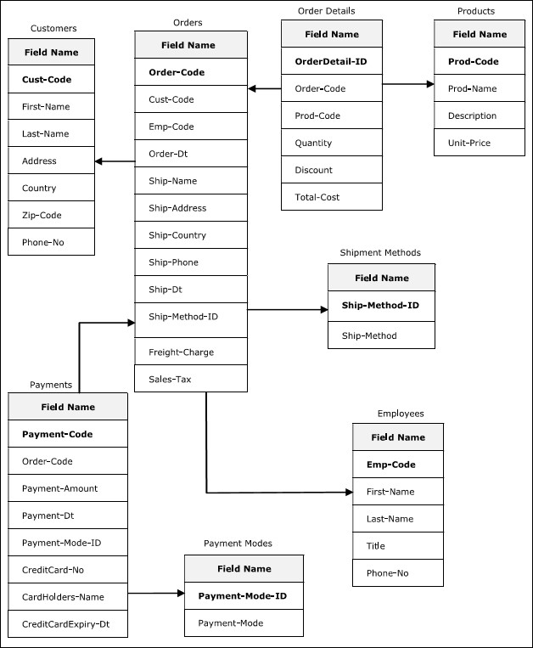



PROJECT ON

Developed by

Name:

Reg. No.:

## NIIT



o

(Project Title)

|  |  |
| --- | --- |
| Batch Code  Start Date  Name of the Coordinator  Name Of Developer  Date of Submission | End Date: |



### NIIT

|  |
| --- |
| CERTIFICATE  This is to certify that this report titled  embodies the original work done by  in partial fulfillment of their course requirement at NIIT.  Coordinator: |



o

ACKNOWLEDGEMENT





#### SYSTEM ANALYSIS

System Summary:

ENTITIES

Number of entities:

Names Of entities:

ATTRIBUTES

Attributes:

#### E/R DIAGRAM



|  |
| --- |
| Number Of Tables:  Structure Of Tables: |

1



2



3



TABLES AFTER DENORMALIZATION



##### PRIMARY AND FOREIGN KEYS



RELATIONSHIPS BETWEEN FINAL TABLES

